PERSONAL INFORMATION
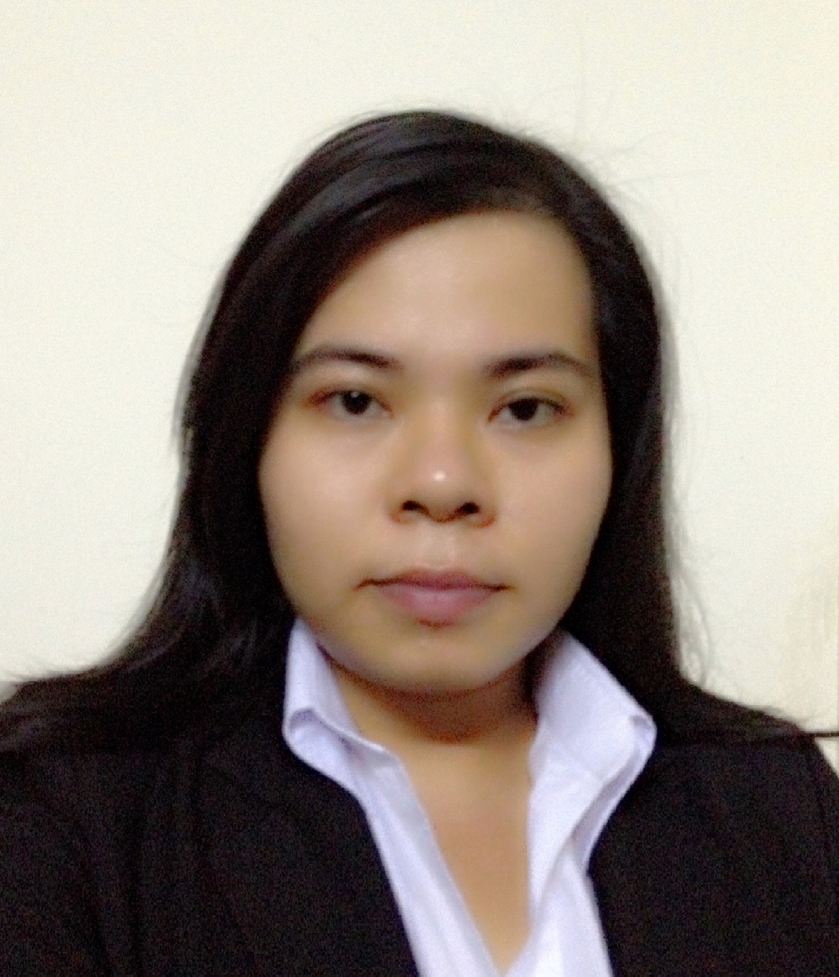
Full name : Cao Vy Minh Quyên
Date of birth : 03/29/1987
Address : 72 – 74 đường số 1A, Ward Bình Trị Đông B, Bình Tân District, HCM City
Mobile phone : 0916.805.206 (Zalo/Viber/Whatsapp/WeChat)
Email : cvmquyen@gmail.com

CAREER OBJECTIVE

Learning and expressing more knowledge when working in a professional environment to accumulate valuable experiences for future promotion and more over, running individual business.
EDUCATION
2012 – 2015 | Graduated Vatel International Business School Hotel & Tourism Management.
2009 – 2012 | Certificate of Draft Design Course from Architect University.
2008 – 2009 | Participated in a "Game Design" Course of NIIT School.
2002 – 2005 | Graduated from Nguyen Hien High School.

ACHIEVEMENT
05/17/2018 – 01/13/2019 Being a supported supervisor who do the best for FO Team in order to maintain hotel’s reputation and maximize the revenue.
08/19/2016 – 03/31/2018 Ensuring the operation works well through hard times such as lacking Human Resources in Blessing 1 Hotel Saigon
Be able to handle most of complaints from guests.
08/03/2015 – 01/31/2016 Fulfill the 3rd internship in Dalat Edensee Lake Resort & Spa.
03/2015 – 05/28/2015 Conducting an individual Career Project named: “An analysis of customers' satisfaction regarding to service quality of Front Office Staff - A case at Dalat Endensee Lake Resort & Spa”.
05/19/2014 – 09/18/2014 Fulfill the 2nd internship in Mia Resort Nhatrang.
09/11/2014 Participated in Gala Event of Hoasen University at Nguyen Van Trang Campus under the position of a Function Manager.
04/01/2013 – 09/15/2013 Fulfill the 1st internship in Dalat Edensee Lake Resort & Spa.
2007 – 2009 Working in FPT Online as a Customer Support
EXPERIENCE RECORD
02/21/2019 till 04/2020 | - Receptionist at Tan Thanh Long Hotel, a 2 star hotel located in District 1, near Ben Thanh Market.  - Key responsibilities:  - Take responsibilities during check-in and check-out process.  - Arrange accommodation for arrival guests.  - Focus on loyal guests and potential guests to have a suitable promotion and/or upselling their booking.  - Follow up hotel’s occupancy, especially in high-season to prevent “over booking”. Focus on Online Booking during Holidays.  - In charge of hotel’s daily expenses and daily revenue (record every transaction and income of the hotel, report directly to the owner).  - Training new employees and support them to become a part of the Front Office Team.  - Being a connection between the operation and the guests, dealing with guests’ requirements and/or complaints but still maintain hotel’s reputation in order to achieve the win – win solution.  - Linking different departments in the hotel into a team to achieve the hotel’s goals.  - Be able to work all the shifts of the Receptionist including Night shift.
05/17/2018 - 01/13/2019 | - Front Office Supervisor, Duty Manager and Sales of Compass Living Joy, a serviced apartment located in District 1.  - Key responsibilities:  - Take responsibilities during check – in and check – out process  - Asign working schedule for Front Office staff  - Make decisions for complicated cases not only to protect customers’ benefits but also maintain the property’s reputation.  - Create promotions, set up rate plans for OTAs (Agoda, Expedia, Booking.com, Traveloka...)  - Handling reservations from different sources such as Travel Agents, Companies, Fanpage...  - Record hotel’s daily expenses revenue.  - Become a connection between departments in order to achieve hotel’s goals.
08/19/2016 – 03/31/2018 | - Main receptionist of Blessing 1 Saigon Hotel, a 3 star hotel located in District 1, near Ben Thanh Market.  - Key responsibilities:  - Take responsibilities during check-in and check-out process.  - Arrange accommodation for arrival guests.  - Focus on loyal guests and potential guests to have a suitable promotion and/or upselling their booking.  - Follow up hotel’s occupancy, especially in high-season to prevent “over booking”. Focus on Online Booking during Holidays.  - In charge of hotel’s daily expenses and daily revenue (record every transaction and income of the hotel, report directly to the owner).  - Training new employees and support them to become a part of the Front Office Team.  - Being a connection between the operation and the guests, dealing with guests’ requirements and/or complaints but still maintain hotel’s reputation in order to achieve the win – win solution.  - Linking different departments in the hotel into a team to achieve the hotel’s goals.  - Be able to work all the shifts of the Receptionist including Night shift.
8/03/2015 – 01/31/2016 | - Trainee at Dalat Edensee Lake Resort & Spa.  - Participated in 2 departments: Housekeeping and Front Office.  - Key responsibilities:  - Housekeeping: worked as the position of Room Attendant: maintain a good quality of accommodation for in-house guests, prepare clean and tidy rooms for next-coming guests.  - Front Officce: worked as the Receptionist of the Resort. Supporting Resort’s employees and also making the check-in and/or check-out process for arrival/departure guests. Also take responsibilities for ensuring available rooms for next day arrival.  - Support other departments during guests’ stay such as assisst the Resort’s Restaurant in set-up events, etc...
05/19/2014 – 09/18/2014 | - Trainee at Mia Resort Nhatrang.  - Participated in 2 departments: Housekeeping and Mojito Bar  Key responsibilities:  - Housekeeping: worked as the position of Room Attendant: maintain good quality of accommodation for staying guests, prepare clean and tidy rooms for coming guests  - Bar: worked as the bartender in Mojito Bar & Restaurant. Able to cover the work of waitress, bartender, cashier, runner and room service. But main key responsibilities are bartender, preparing drinks for guests, receiving order through phone call.
09/30/2013 – 04/30/2014 | - Trainee at Vatel Saigon Restaurant as a Supervisor.  Key responsibilities:  - Kitchen: Leading the 1st year students in organization and assignment students for an effective work.  - Restaurant: Leading the 1st year students in organization and assignment students for an effective work. Supporting students to achieve the quality of service.  - Trainee at Movenpick Hotel Saigon (Eastin Grand Hotel Saigon nowaday).  Key responsibilities:  - F&B Department: Waitress, serving buffet in Café SaiGon Restaurant, serving for Banquet; Slate the Bar.  - Front Office: Receptionist, helping staffs in preparing keys room, check-in process.  - House Keeping: Room Attendant, helping staffs in making rooms.  - Casual labor of Vatel Restaurant as waitress.
04/01/2013 – 09/15/2013 | - Trainee at Dalat Edensee Lake Resort & Spa.  - Participated in 3 departments: Kitchen, F&B and FO.  Key responsibilities:  - Kitchen: Prepare duty meals for staffs.  - F&B: Waitress at Riesling Restaurant.  - Front Office: Receptionist, prepare bookings for guests, check rooms, prepare profiles, print passports.
2012 - 2013 | Participated in some events of Vatel Restaurant in Hochiminh City.

SKILLS

Living and studying in an International Environment helps the writer to achieve some basic knowledge of computer skills like MS Word, Excel and Power Point. Those programs are the most common applications that the we use most in daily studying and working.
With several years of internship and studying in different industries help the writer to develop an observation skill, which is one of the most important skill nowaday.
Combine with a critical thinking, the writer can be able to learn new knowledge affectively and logically.
HOBBIES

Although a busy life outside, I prefer enjoy the free time with my family, listening to the music.
Sometimes I travel to Dalat City, my favorite place to relax, refresh myself and recover energy in order to be ready for facing with challenges.
Prefer working under high pressure in order to challenge myself.

